Project 1: Deploy a Comprehensive Identity and Governance Management Solution for Scoop Mall Ltd
Objective
The aim of this project is to protect Scoop Mall Ltd from security threats like spam mail, phishing attacks, and unsafe email attachments. Also manage identity and access privileges for the IT team based on their specific job roles.
- Security: Protect internal and external users from threats like spam, phishing attacks, and unsafe attachments, while also ensuring that IT access privileges align with specific roles.
- Scalability: Focuses on enabling the company's growth and adaptability while maintaining secure and manageable operations in Microsoft 365.
- Resiliency: Ensuring business continuity, minimizing downtime, and maintaining security despite potential disruptions
- Management: Maintaining secure operations, enabling effective IT administration, and ensuring consistent access management for both internal and external users.

Project Task
The task is to deliver a solution that ensures security and efficiency for Scoop Mall Ltd.’s digital operations, while adhering to best practices in Microsoft 365 identity and access management.
1. Email Protection:
Step1: Configuration of Anti-phishing policies
I implement security measures to protect Scoop Mall Ltd from spam,phishing, and malicious attachments.
I log in to Microsoft defender and set up anti-phishing policy to protect the company from malicious attacks.i also turn the policy on so that it will take effect. i also set the Action it will take when phishing emails come in which is to quarantine and quarantine policy is only Admin .

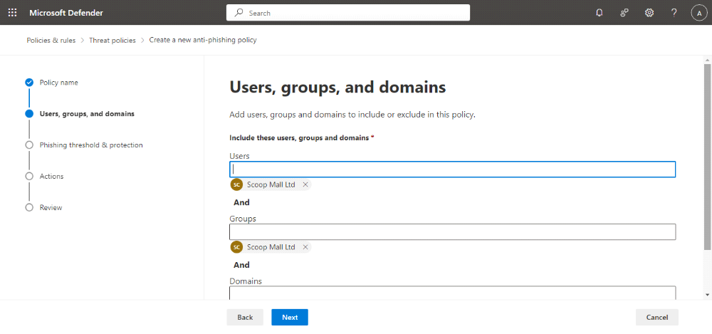

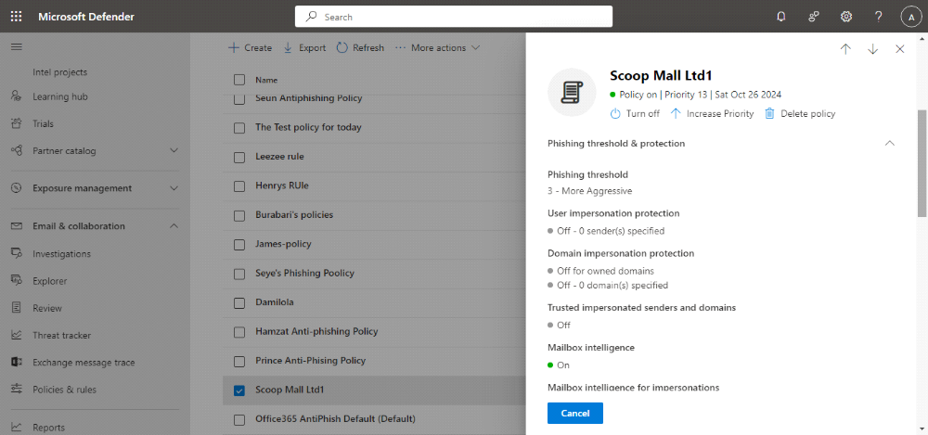

Step2: Configuration of Anti-Spam Policies
I implemented an inbound Anti-spam policy to Protect Company's email from spam, including what actions to take if spam is detected. i also set the Action it will take when phishing emails come in which is to quarantine and quarantine policy is only Admin. also i included and excluded some Users.

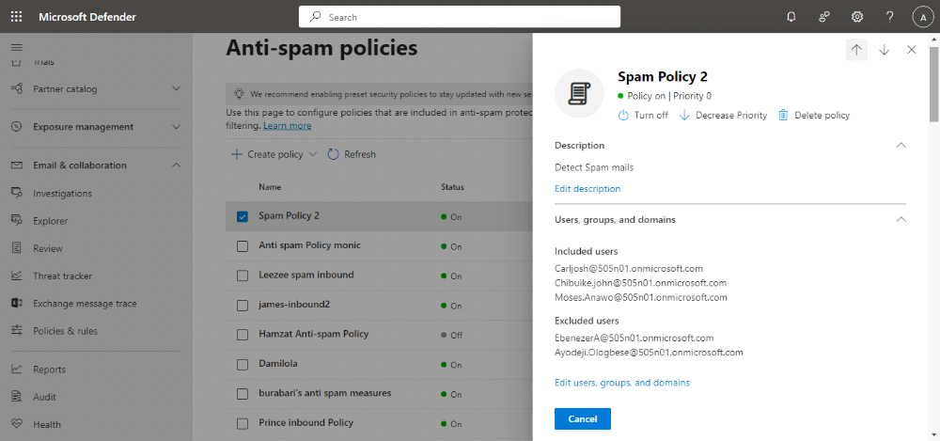

Step3: Configuration of Anti-Malware Policies
I implemented Anti- malware policy to the Company's email from Malware, including what actions to take and who to notify if malware is detected
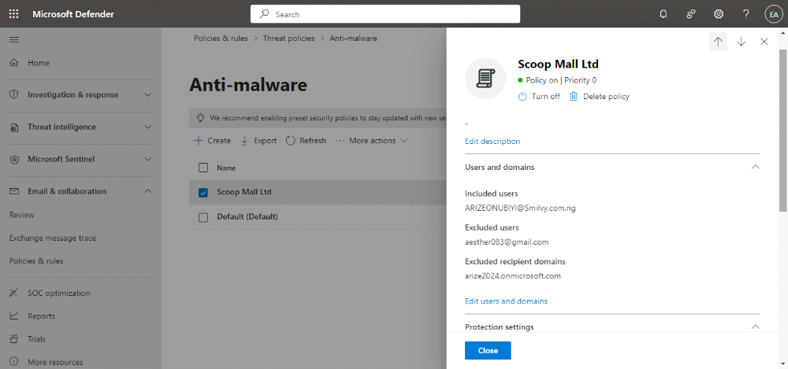

Step4: Set Up Safe Attachment Policies
This policy help protect the organization by scanning email attachments for malware or suspicious content
To achieve this i logged in to Microsoft Defender portal, navigate to Email &Collaboration,policies and rules,threat policy and then Safe Attachment and created one.
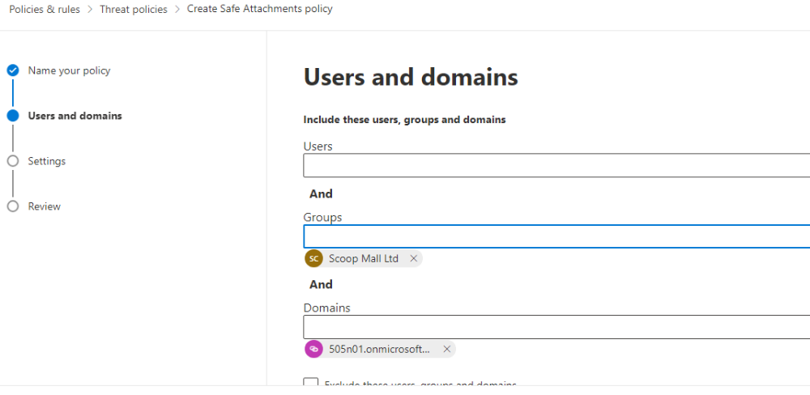
The domain i selected for the safe Attachment policy shows that the policies is applied to all email address within that domain.
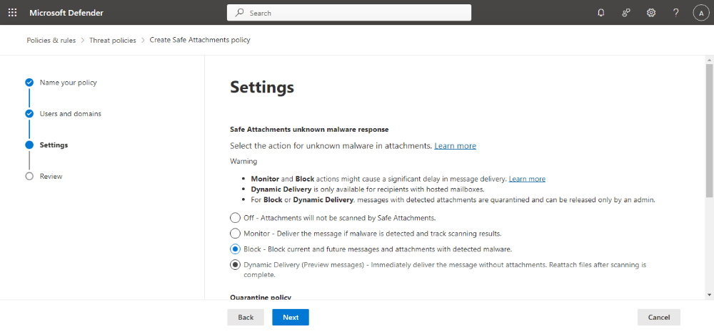
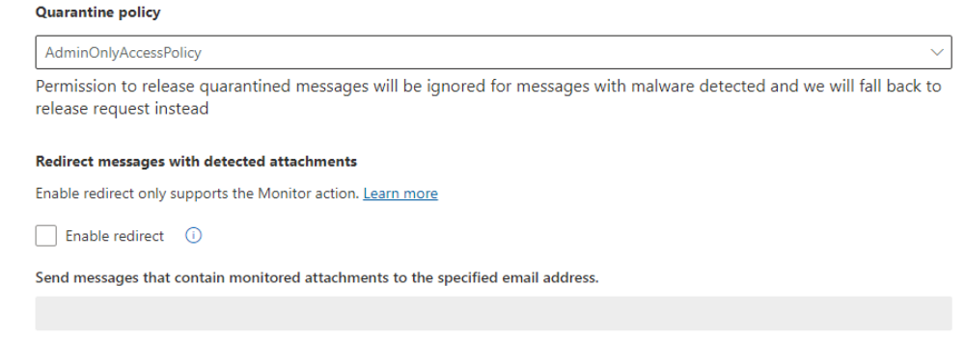
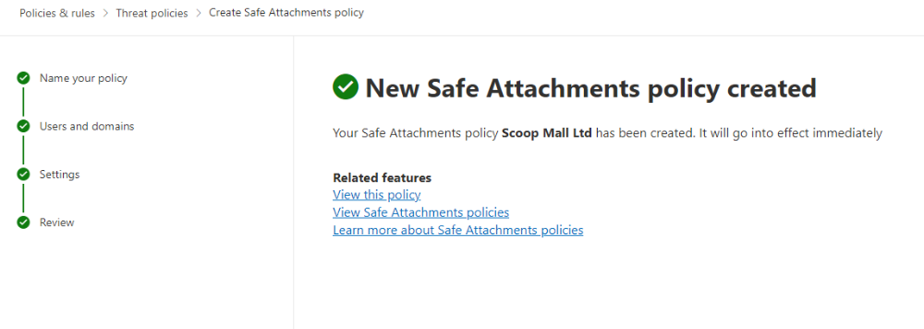

2. Identity Management
2a. I use Microsoft Entra ID to enable Multifactor Authentication (MFA) for all Users,but i excluded myself.
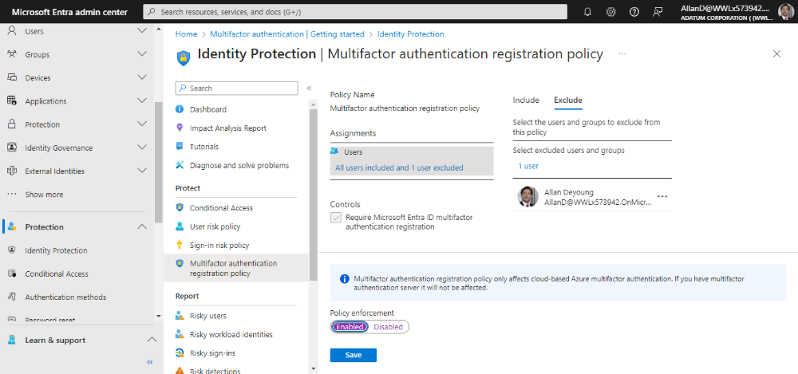
I implemented Conditional Access policies to regulate access to company resources based on user location, device, and application for both internal and guest users.
.
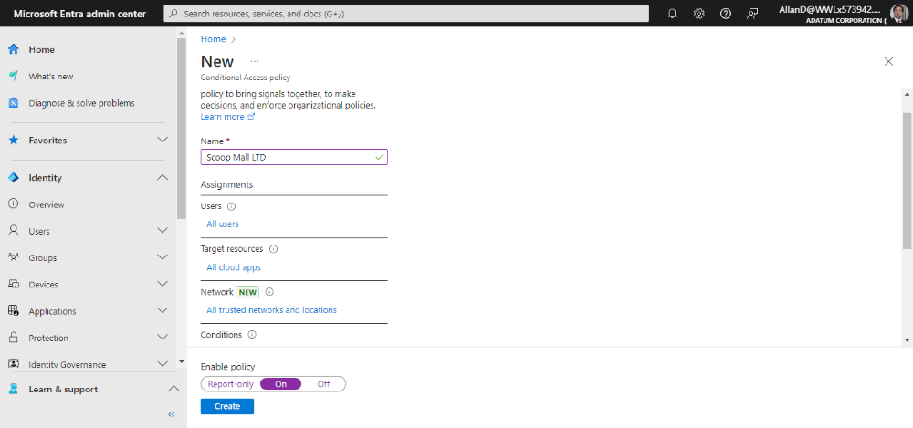

For Guest Users Access
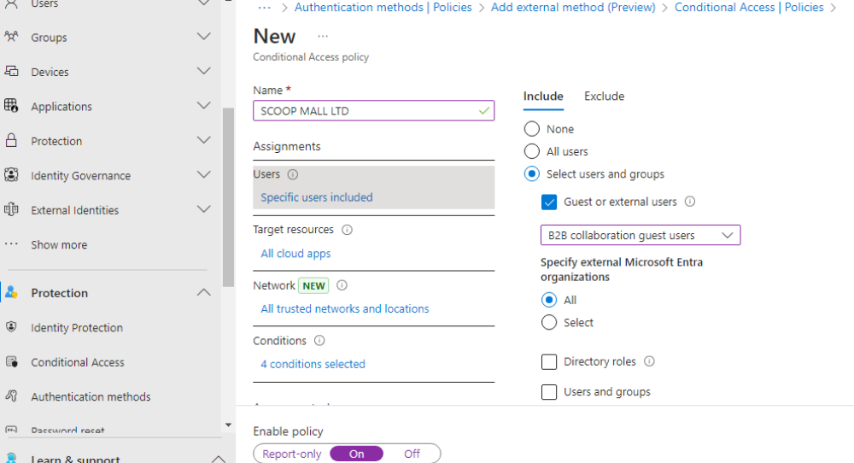

3. Access Management and Role-Based Access Control (RBAC):
3a. I Administer access privileges for the IT team according to their roles, such as Help-desk, Security Admin, and Global Admin.,I selected two users from the IT Team i created and assign them the listed roles and also the roles expiration date.

For Help-desk Administrator
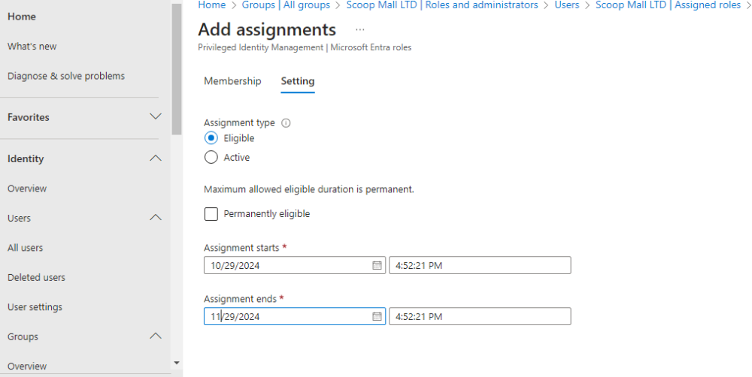
For Security Administrator
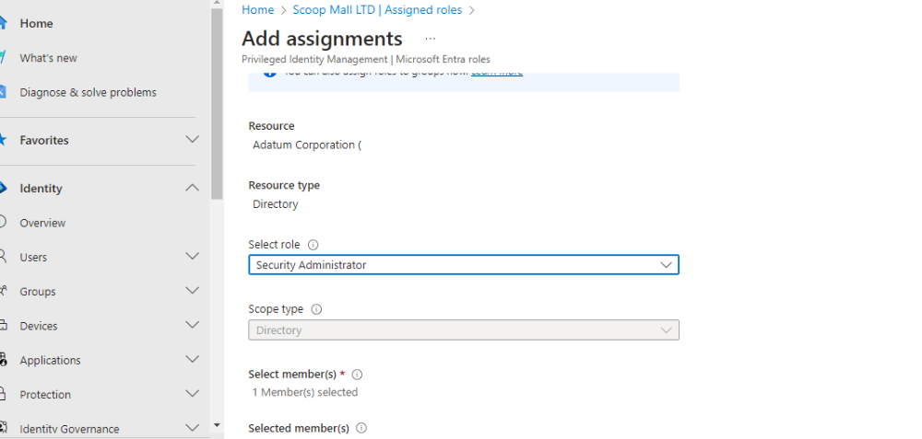
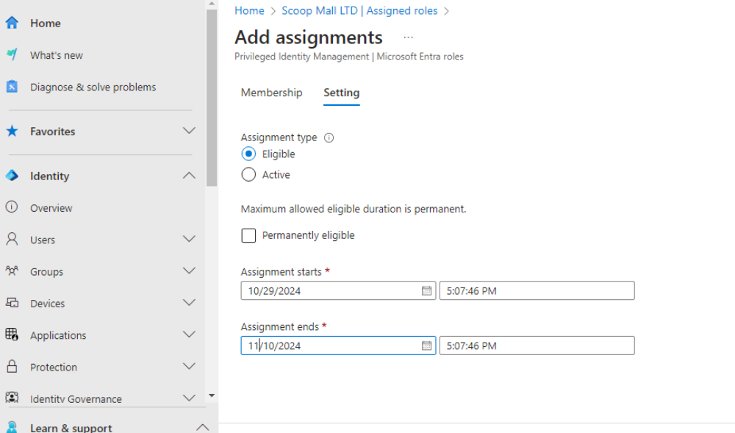

For Global Administrator
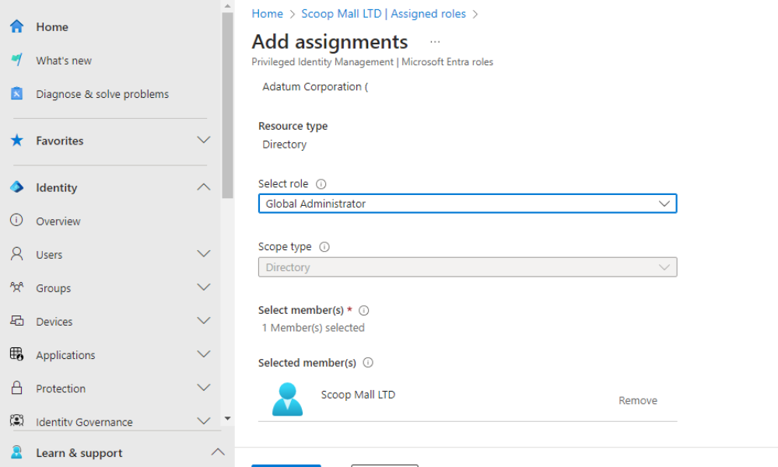
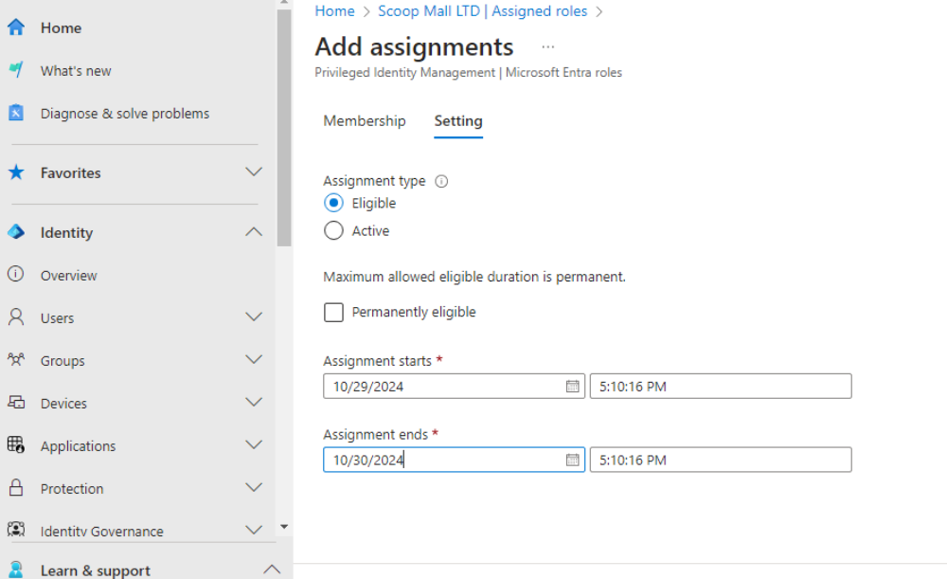
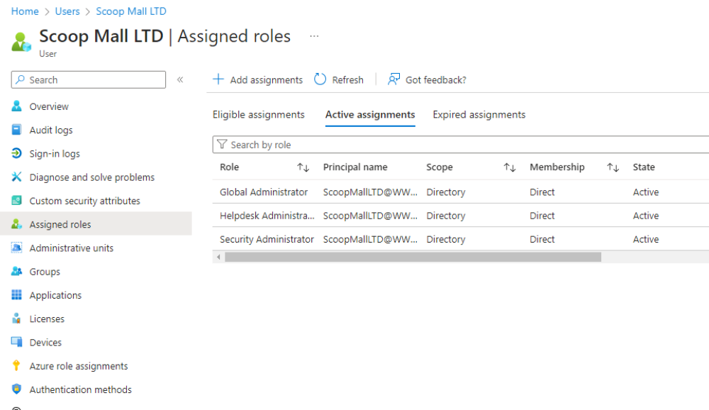

3b. Using Microsoft Entra ID Privileged Identity Management (PIM) to manage and monitor access to sensitive resource
In the PIM dashboard, i selected Audit history to view logs of role assignments, activation's, and other changes related to privileged roles.
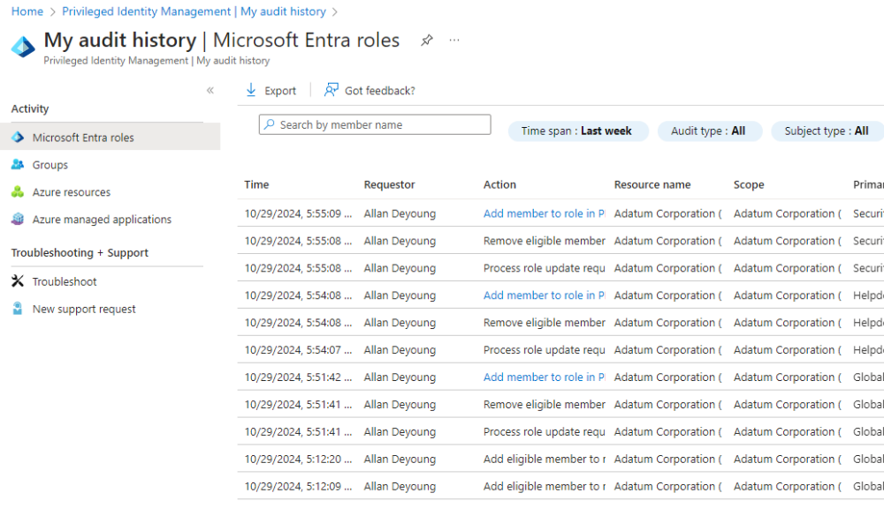

4. Implement self-service password reset and account recovery processes.
Implement self-service password reset
I log in to Microsoft Entra ID, Navigate to protection,selected Password reset. i highlighted all and save which means any one in the organization can reset their own password without the help of an admin
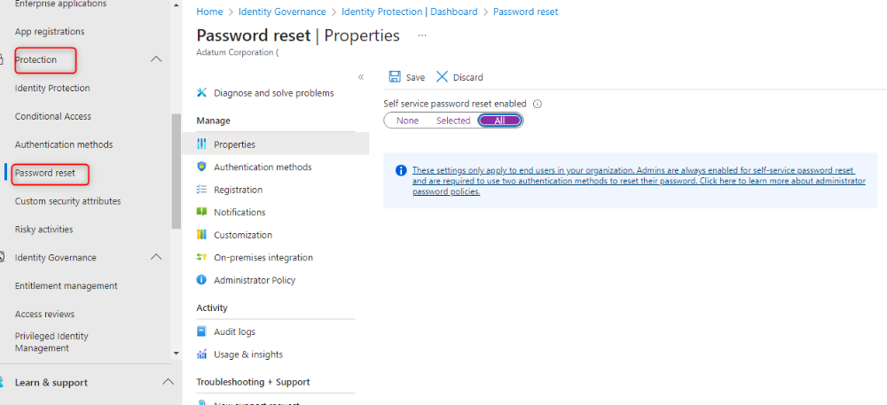

Authentication method
I also set up the authentication method which is only mobile app notification. Also Registration which required Users to register when signing in and number of days before users are asked to re-confirm their authentication.

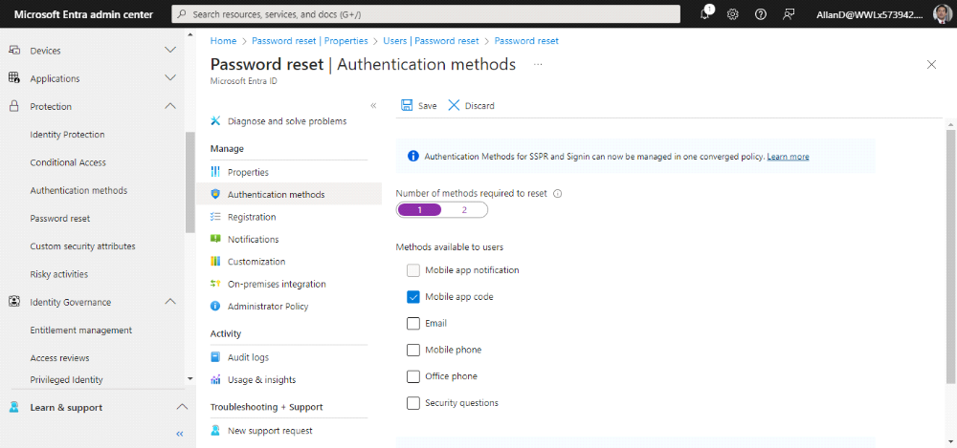

Number of days before users are asked to re-confirm their authentication.
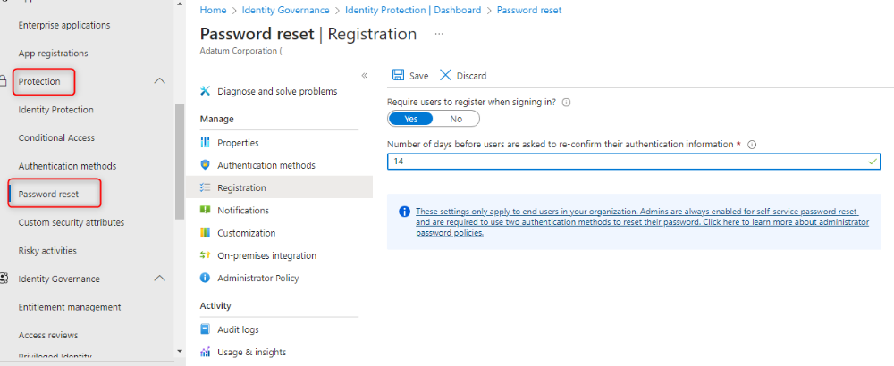

Testing the SSPR and account recovery processes
Adele account was used to run the reset, below is the screenshot.
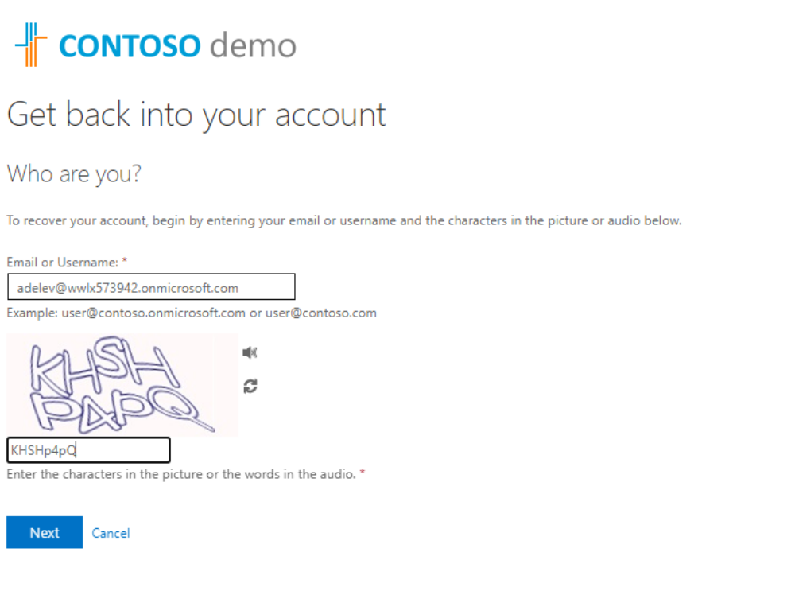

Adele entering the authentication number
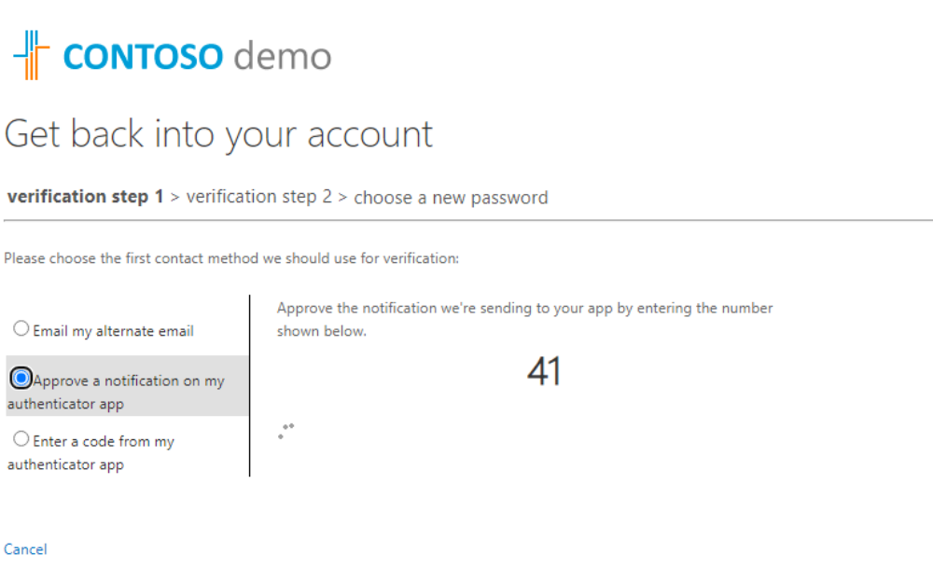
Adele initiating a new password
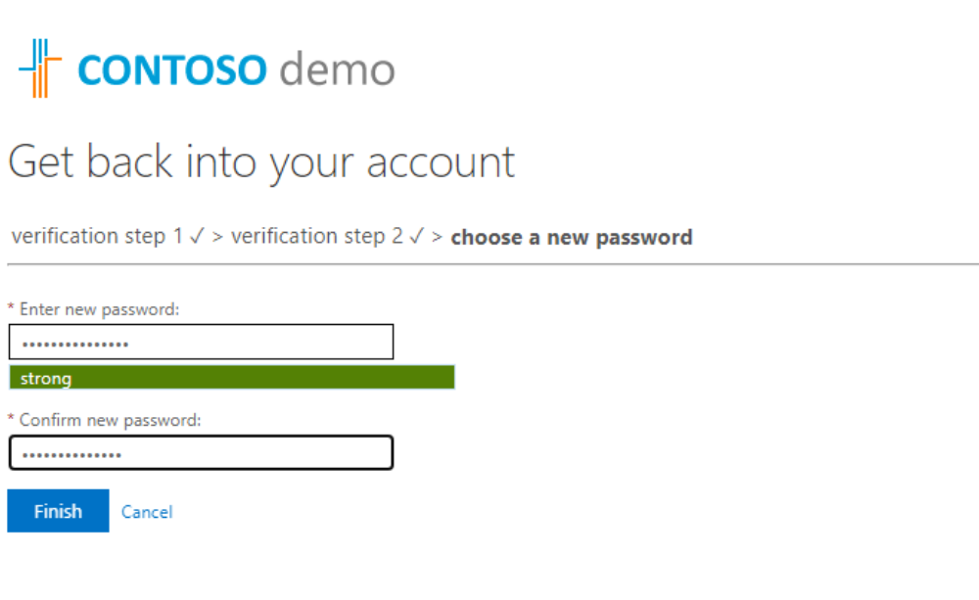

Password successfully changed
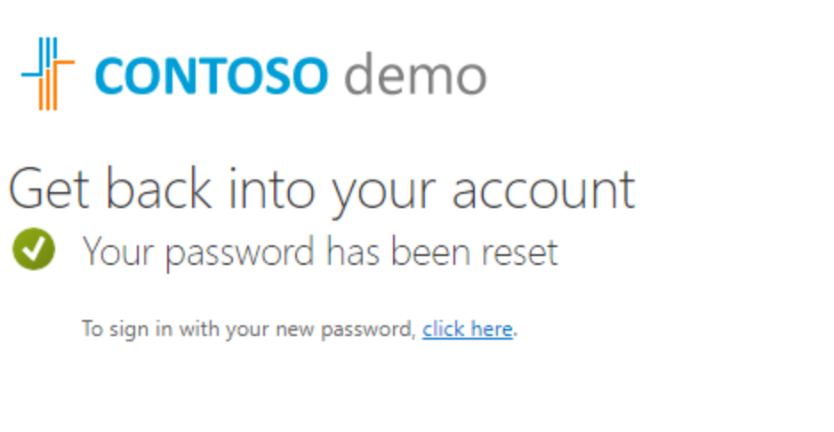
5. Governance and Reporting:
5a. Set up auditing and reporting in Microsoft 365 Security & Compliance Center to monitor user activities and detect potential security breaches.
I log into the admin Compliance Center.
In the left pane, i click on Audit under Solutions.
Enabled, the audit logging by clicking on Start recording user and admin activity then click on search, this will capture all the activities.
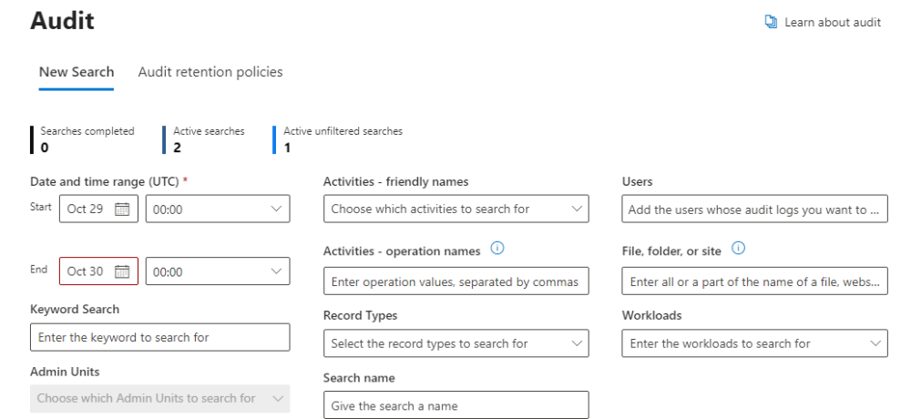

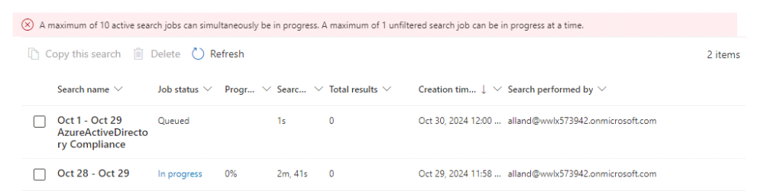

5b. Configure alerts for suspicious sign-in attempts and unusual activity.
I log in to Microsoft Defender admin portal
Navigate to Email and collaboration,then policies and rules
selected Alert policies,clicked on create new policy,set up the alert
name,description and the recipient who will receive alert when it
Triggers.
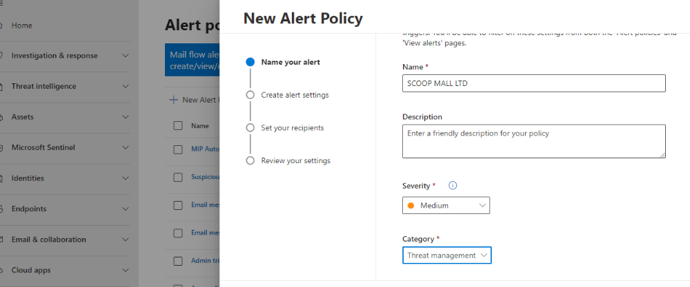
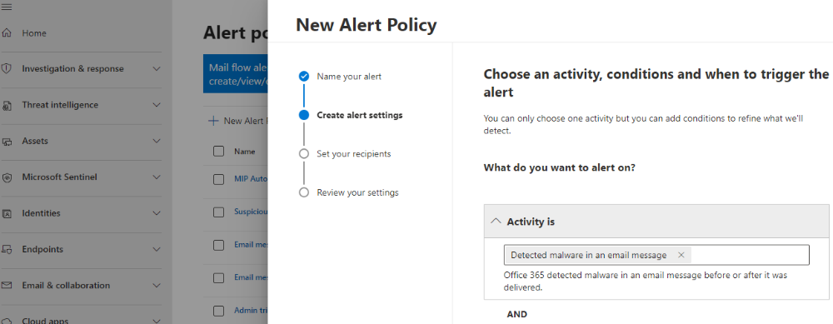

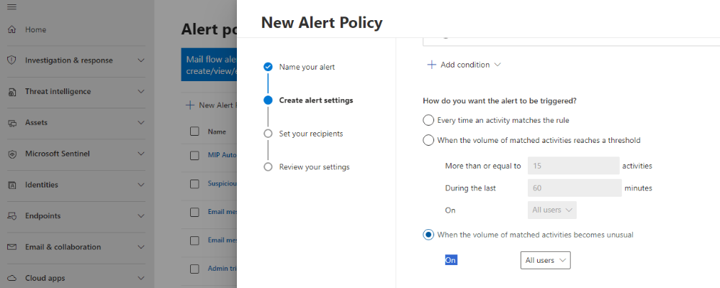
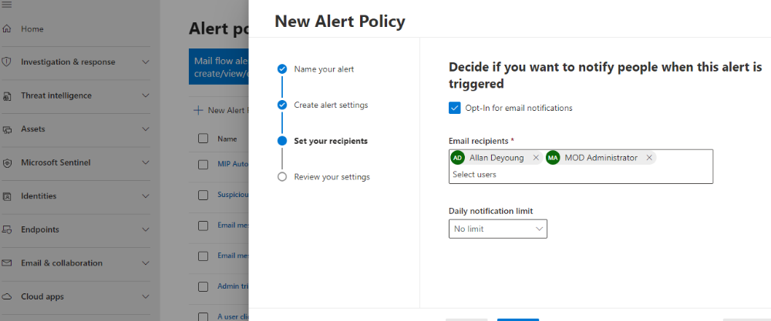

I also configure Sign-in-risk policy, to help protect against suspicious sign-ins that may indicate compromised accounts, such as attempts from unusual locations, unfamiliar devices, or other potentially risky behaviors.
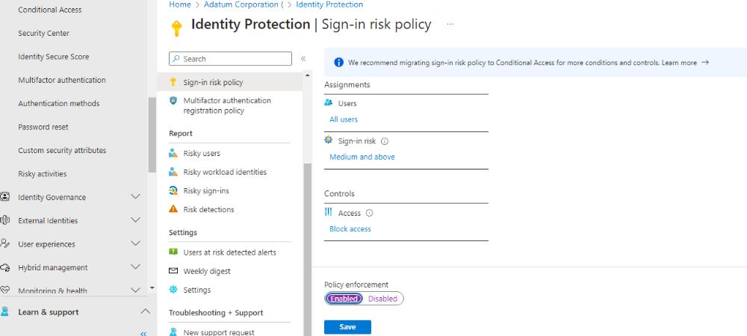

5c. Generate monthly governance reports to track the usage of privileged accounts.
Firstly on Entra ID Admin center,i make sure that the PIM is enabled, Set up privileged roles like Global Administrator, Exchange Admin, etc.

6. Compliance and Data Protection:
6a. Use Data Loss Prevention (DLP) policies to prevent the unintentional sharing of sensitive information.
- To achieve this, I log in to Microsoft Purview, I navigated to Data Loss Prevention,clicked on polices, i click on create policy to start my own policy.Also there are already made template for the policy but i choose to create a custom policy since i don't know the kind of policy the organization want.
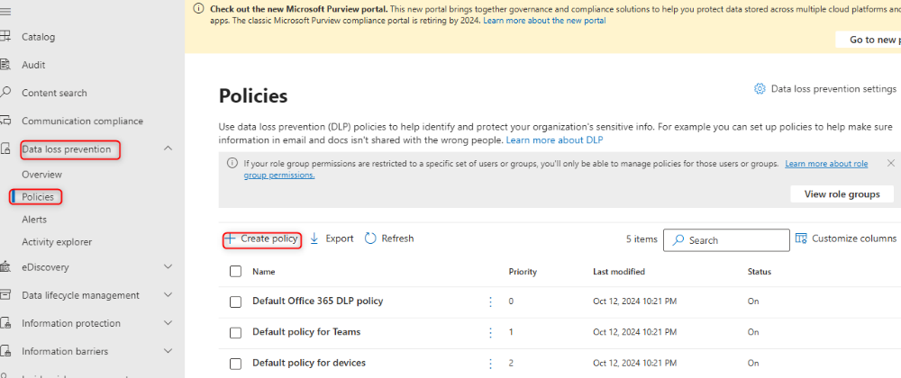
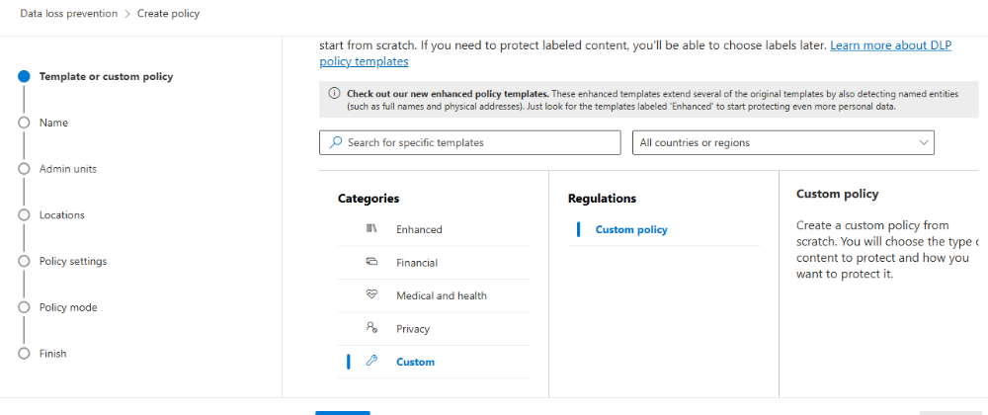

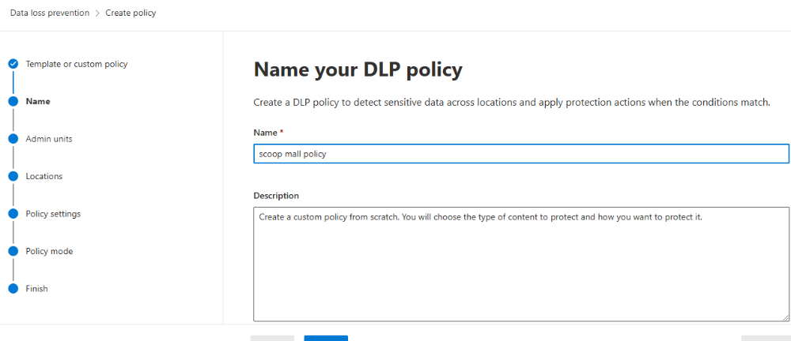

I choose the location where i want the policy to apply
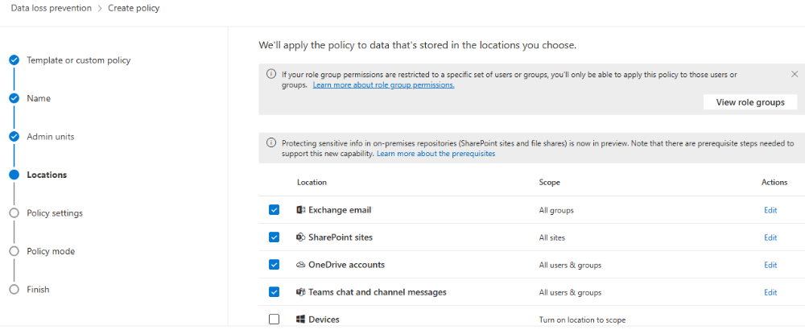
Define policy setting, i choose create and customize advance DLP rules
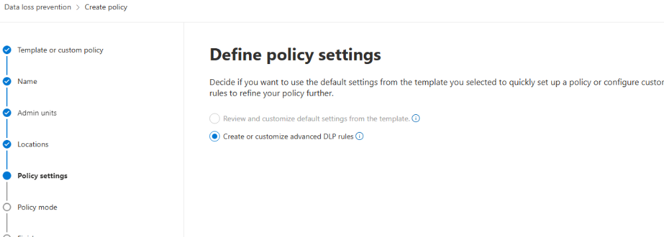

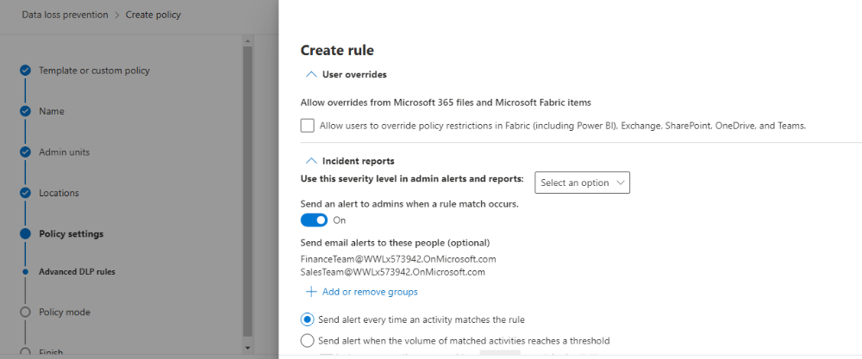

Policy rule was configured and created
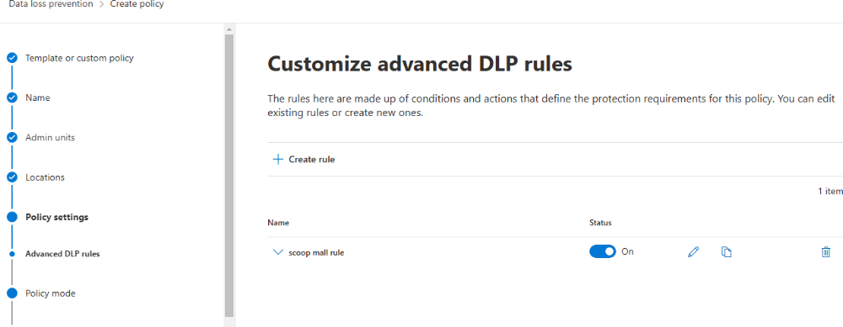
DLS successfully implemented
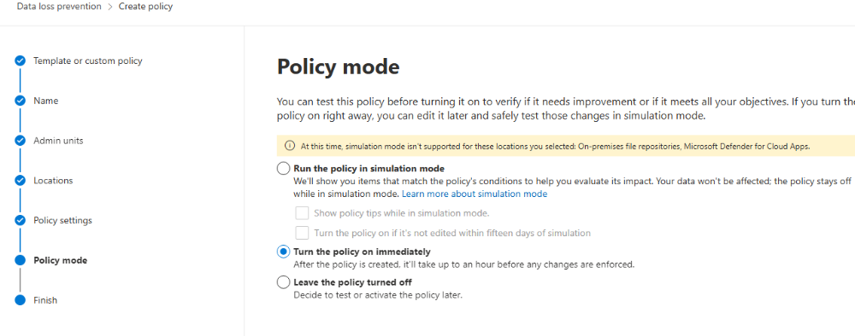
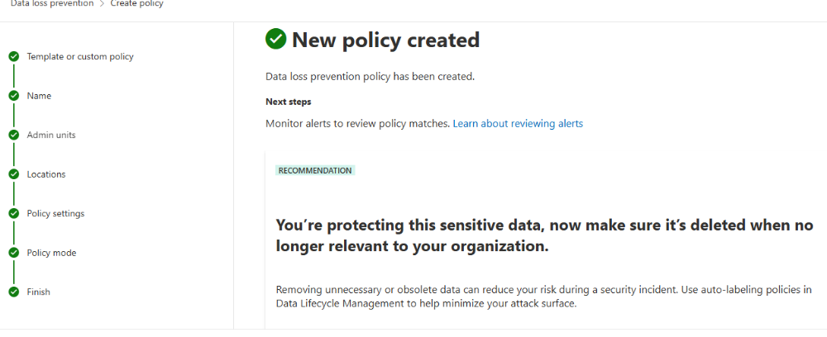

6C. Configure Retention Policies to ensure compliance with Scoop Mall Ltd data retention requirements.
- To achieve this, I logged in to Microsoft purview, Navigate to Data lifecycle management,Microsoft365,Retention policies, and then new retention policy.
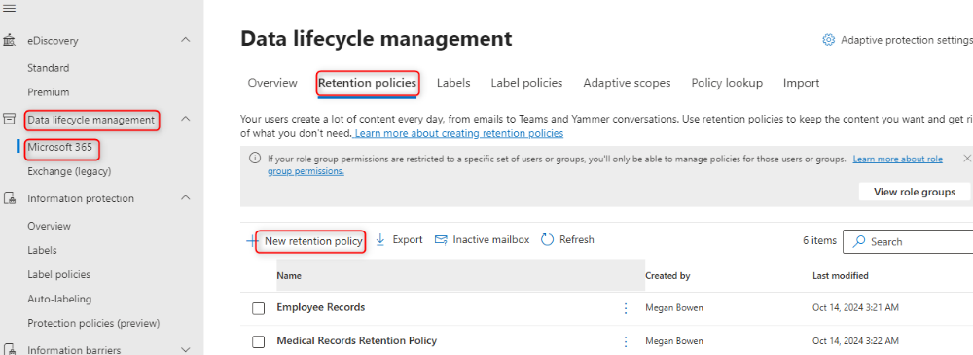
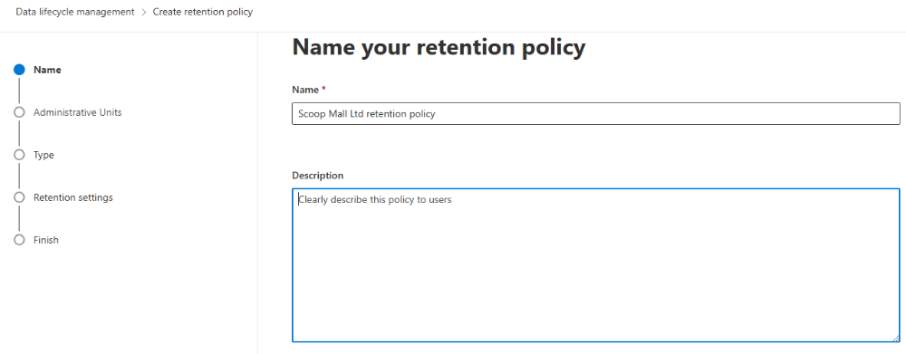
I then added the Admin Unit i created in Microsoft Exchange which i want the policy to apply
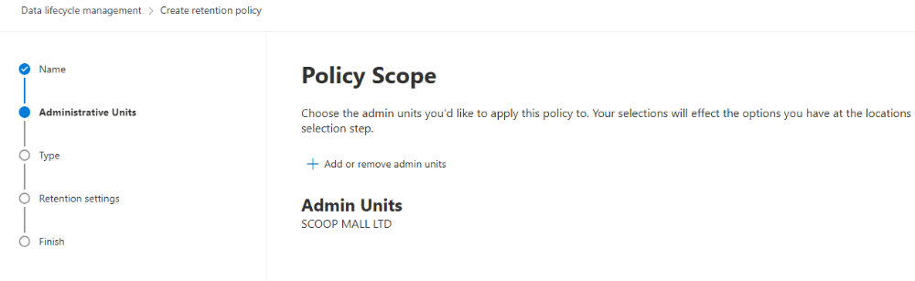
I choose the type of retention policy to create which is static because this will allow me to choose locations that contain the content i want to retain
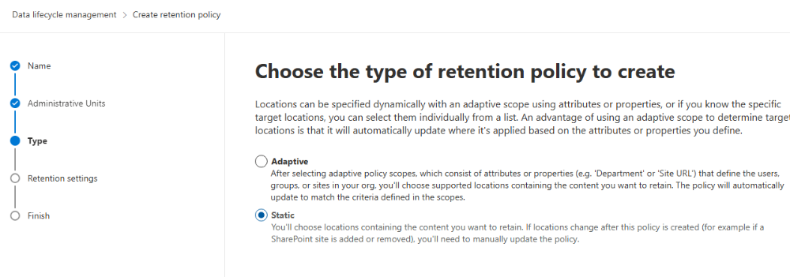
I then selected where to apply the policy and turned it on
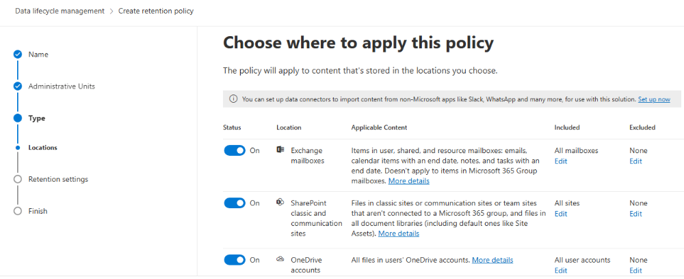
I set set up the specific time i want the policy to last, start the policy when item was created, at the end of policy delete item automatically
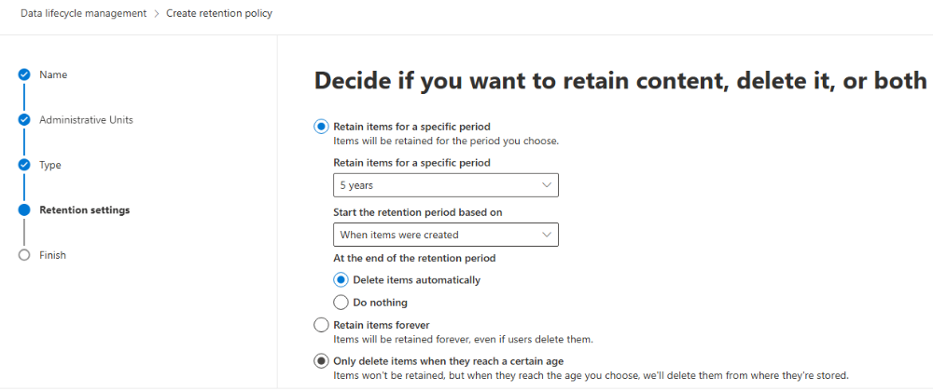
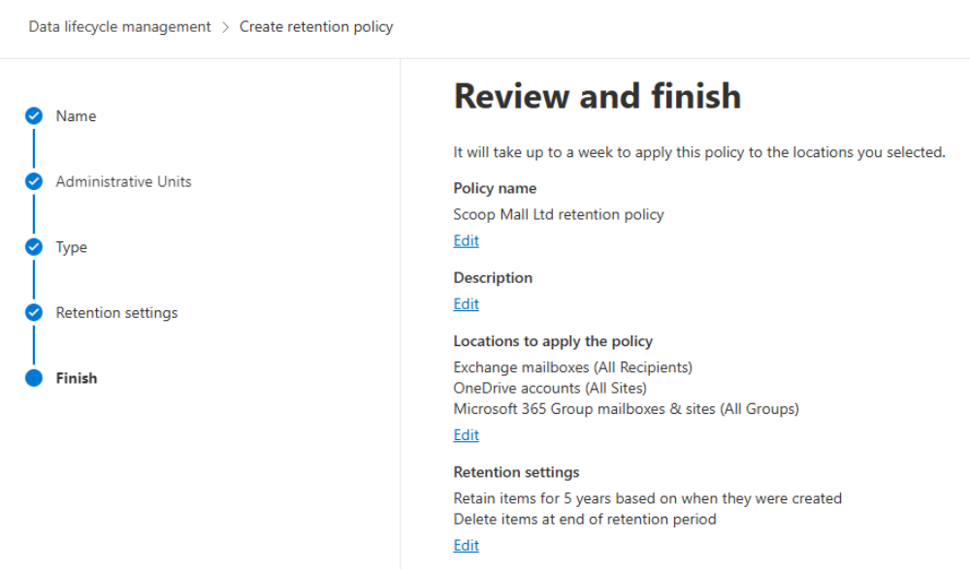
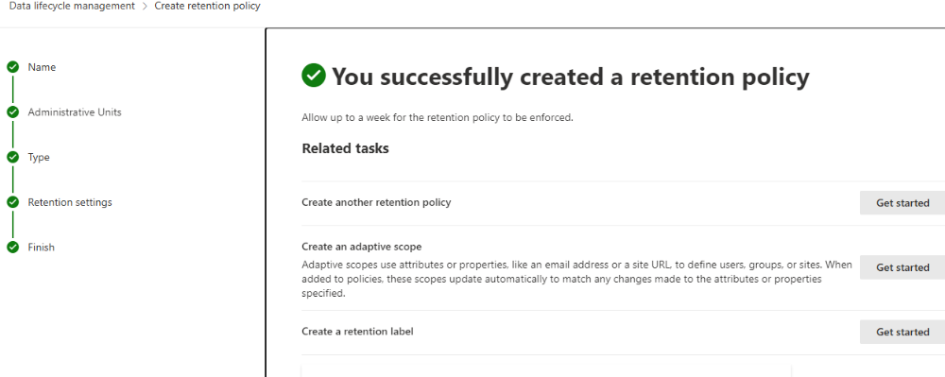

Conclusion
Deploying a comprehensive identity and governance management solution for Scoop Mall Ltd will significantly enhance the security and efficiency of its Microsoft 365 environment.By focusing on identity management and robust governance, the project will mitigate risks from threats like phishing, spam, and unsafe attachments, protecting both internal and external users. Role-based access controls will streamline identity and access management for the IT team, ensuring that privileges align with specific job functions.

